Openpyxl

<https://doitnow-man.tistory.com/159>

<https://openpyxl.readthedocs.io/en/stable/tutorial.html>

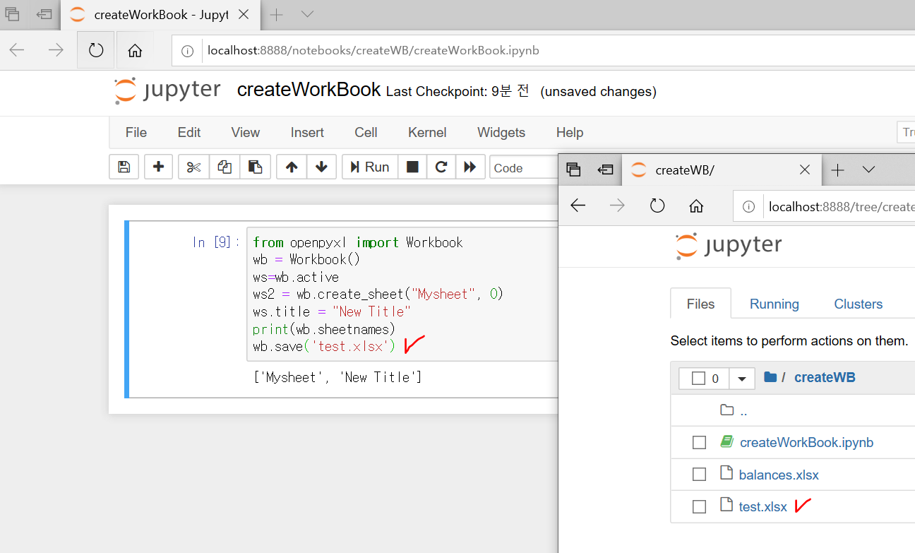

#------------------------------------------------------------

import openpyxl

import numpy as np

# 간단한 처리라 numpy 사용배제 가능, 특히 microbit 메모리가 작아 사용배제

wb=openpyxl.load_workbook('analogdata10.xlsx')

sheet=wb.get_sheet_by_name('analogdata10')

#sheet

#sheet['A2'].value

multi_cells=sheet['A2':'B50']

# 데이타가 있는 열 개수 표시

print('sheet max row is : ',sheet.max_row)

sumValueL=sum([row[0].value for row in sheet['A2':'A74']])

print('total sum : ', sumValueL)

#평균은 numpy 사용

meanValueL=np.mean([row[0].value for row in sheet['A2':'A74']])

print('mean is : ', meanValueL)

stdValueL=np.std([row[0].value for row in sheet['A2':'A74']])

print('standard deviation : ', stdValueL)

minValueL=min([row[0].value for row in sheet['A2':'A74']])

print('min value is : ', minValueL)

maxValueL=max([row[0].value for row in sheet['A2':'A74']])

print('max value is : ', maxValueL)

print('right Line Sensor ')

sumValueR=sum([row[0].value for row in sheet['B2':'B74']])

print('total sum : ', sumValueR)

#평균은 numpy 사용, 간단한 계산이라, (max+min)/2로

meanValueR=np.mean([row[0].value for row in sheet['B2':'B74']])

print('mean is : ', meanValueR)

stdValueR=np.std([row[0].value for row in sheet['B2':'B74']])

print('standard deviation : ', stdValueR)

minValueR=min([row[0].value for row in sheet['B2':'B74']])

print('min value is : ', minValueR)

maxValueR=max([row[0].value for row in sheet['B2':'B74']])

print('max value is : ', maxValueR)

gapValue=meanValueL-meanValueR

print('평균값 차이',gapValue)

if gapValue>0 :

print('왼쪽 센서 값이 %d 만큼 더 높음'%gapValue)

else :

print('오른쪽 센서 값이 높음')

for row in sheet.rows:

print([col.value for col in row])

#------------------------------------------------------------

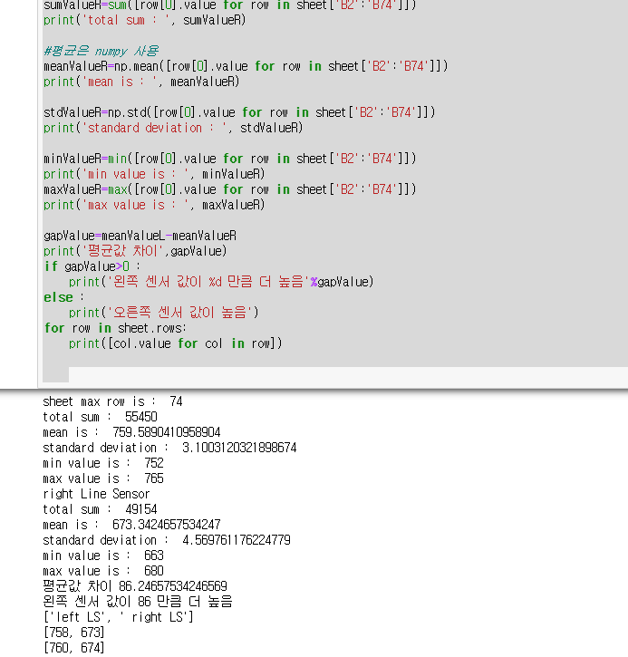

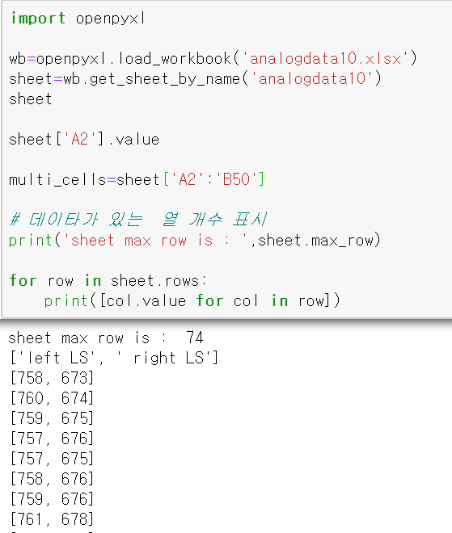

#---------------------------------------------------------

import openpyxl

wb=openpyxl.load_workbook('analogdata10.xlsx')

sheet=wb.get_sheet_by_name('analogdata10')

sheet

sheet['A2'].value

multi_cells=sheet['A2':'B50']

# 데이타가 있는 열 개수 표시

print('sheet max row is : ',sheet.max_row)

for row in sheet.rows:

print([col.value for col in row])

#---------------------------------------------------------

